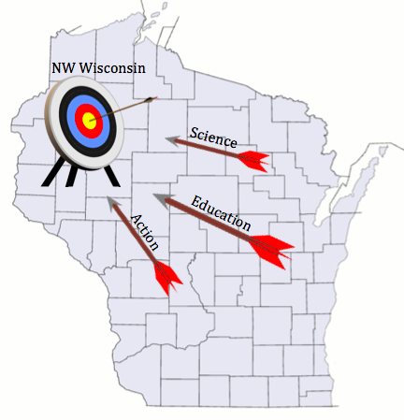

**NAME___________________________________________TELEPHONE_______________________**

**ADDRESS___________________________________________________________________________**

**EMAIL______________________________________________________________________________**

**NUMBER ATTENDING_______ ($20 each prior to June 5; $25 after)**

**AMOUNT ENCLOSED________ (Receipt desired? ___Y, ___N)**

**Make checks payable to Vermillion Lakes Association. Send to: Helen Blumer, Conference Coordinator; 2155 9th Street, Cumberland, WI 54829**

**For more information visit** <https://sites.google.com/a/csdmail.com/ewm/> **or call or email**

**Dave Blumer, Lake Educator at 715-642-0635 or** [dblumerleaps@gmail.com](mailto:dblumerleaps@gmail.com)

**“Targeting”**

**Eurasian Water Milfoil**

A Conference for lake organizations on lakes with and without EWM, dedicated to sharing experiences and learning how to deal with the issues caused by EWM.

**2015 Eurasian Water Milfoil Conference**

**“Making Good Lakes Better”**

Registration 7:30 am

Program 8:25am – 4:45pm

**About the Conference**

This event is a **learning** and **sharing** opportunity with three goals: sharing EWM management experiences, learning about WDNR grant priorities and the future of grant programs, and discussing the benefits of groups coming together to cooperatively address the issues caused by EWM in a lake. This event will provide a better perspective of how we can stand together against EWM to “make good lakes better”. **YOU ARE NOT ALONE**!

There will be guest speakers and presentations, a chance for you to ask questions and share your insights and opinions, and of course beverages, snacks, and lunch. And take the time to view EWM educational and informational displays prepared by our Island City Academy charter school student partners. They are eager to discuss what they have done. Find out what we already know, these kids are amazing!

**The Registration Fee for the conference is $20 until June 5th and $25 thereafter.**

For more information about EWM and a full agenda for the conference, visit <https://sites.google.com/a/csdmail.com/ewm/>, email [dblumerleaps@gmail.com](mailto:dblumerleaps@gmail.com) or scan the QR code on the right.

To register, complete the form below and return it with your check to the address listed.

**………………………………………………………………………………………………………………………………………………………………………………………….....**

June 20, 2015

Cumberland Middle School

980 8th Avenue, Cumberland, WI 54829

Co-sponsored by Vermillion Lakes Association, Sand Lake Management District, and Island City Academy